PIJIS Template

Research title should be concise, informative, and accurately reflect the study, ideally 10-15 words
Joanna E. Dela Cruz¹* Sandra H. Limjap²
¹Bataan Peninsula State University, Balanga Campus, College of Education, Philippines
²University of Toronto, St. George Campus, College of Science, Canada
*corresponding author: jedelacruz@bpsu.edu.ph

Abstract
An effective research abstract must furnish a succinct synopsis of the essential components of the research investigation, highlighting the background, objective, methodology, results, and conclusions. It should be composed with clarity and precision, facilitating readers' comprehension of the principal aspects of the study without necessitating a full perusal of the paper. A good research abstract is composed of approximately 150-200 words.
Keywords: please include four to six (4-6) keywords

Introduction
A good introduction for a research journal article is an important opening section that introduces the study. It starts by giving some background information about the general topic or field in which the research is being done. This helps readers understand the context and why the study is relevant. Then, the introduction clearly states the specific research problem or question that the study is trying to address. This tells the readers what the study is all about and what the researchers are trying to find out.
After that, the introduction explains why the research problem is important and why it matters. It highlights any gaps in existing knowledge and how the study aims to fill those gaps. This helps readers see the significance of the research and why it's worth paying attention to.
Next, the introduction outlines the objectives or hypotheses of the study. These are the goals the researchers want to achieve or the ideas they want to test through their research.
The introduction also mentions the scope of the study, which means what aspects will be covered and what won't be included. It may also mention any limitations or restrictions that the researchers had to deal with.
In addition, the introduction gives a brief overview of the research methods used in the study. This helps readers understand how the research was conducted and how reliable the findings are likely to be.
Finally, the introduction outlines how the rest of the paper is organized. It tells the readers what they can expect to find in the following sections and how the study's results and conclusions will be presented.
A well-crafted introduction grabs the readers' attention and gives them a clear sense of what the research is all about. It sets the stage for the rest of the journal article, making readers eager to learn more about the study's findings and insights.
Methods
The methods section describes the research design, participants or subjects, data collection procedures, and data analysis methods used in the study. The researchers can describe this section by describing the overall research design used in the study. Specify whether it was an experimental study, observational study, survey, case study, or any other appropriate design. Explain the rationale behind choosing this design and how it aligns with the research objectives.
This section also describes the characteristics of the participants or subjects involved in the study. Include details such as the total number of participants, their age range, gender distribution, demographic information, and any specific criteria for inclusion or exclusion from the study. If relevant, mention any randomization or allocation methods used.
The method should clearly outline the procedures used to collect data. For each data type (e.g., surveys, observations, interviews, experiments), explain how the data were gathered, the instruments or tools used, and any established reliability and validity of these instruments. If applicable, detail any modifications or adaptations made to existing measures.
If applicable, it can numerate and define the variables studied in the research. Identify the independent variables (factors being manipulated or observed) and the dependent variables (outcomes being measured). If there are any control variables or covariates, mention them as well.
In this section, the statistical or analytical methods employed to analyze the data is also described. Specify the type of statistical tests or software used, and explain how these methods were chosen to answer the research questions or test the hypotheses. Include information about the significance level or alpha value used for hypothesis testing.

Methods can also include any ethical considerations in the research, particularly if the study involved human or animal subjects. Describe how informed consent was obtained, how confidentiality was ensured, and how any potential risks or benefits to participants were managed.
Additionally, this section provides a step-by-step description of the research procedure, including the sequence of activities and the timeline. This section should be detailed enough to allow other researchers to follow the same steps and replicate the study accurately.
Lastly, the researcher can include here the steps taken to ensure the validity and reliability of the data and measurements. If applicable, mention any pilot studies or pre-testing done to validate the research instruments.
Results
The "Results" section is a critical part that presents the findings of the study in a clear and organized manner. This section provides a comprehensive and detailed account of the data collected during the research, the statistical analyses performed, and the outcomes of those analyses.
Results present the raw data in a clear and organized manner. Use tables, graphs, figures, or charts to illustrate the data effectively. Each table or figure should have a clear title and be numbered consecutively. Ensure that the data presentation is easily understandable and relevant to the research question.
This can include descriptive statistics, such as mean, median, standard deviation, range, or percentages, to summarize the main characteristics of the data. These statistics provide a general overview of the data before conducting any inferential analyses.
Moreover, in this section the results of the inferential statistical tests used to test the research hypotheses or answer the research questions are presented. Include the test statistic, degrees of freedom, p-value, and any effect sizes if applicable. Be sure to interpret the statistical results in the context of the research objectives.
If the study involved hypothesis testing, clearly state whether the null hypothesis was rejected or accepted for each hypothesis. Explain the implications of these findings and how they relate to the research question.
Whenever applicable, present the results of any subgroup analyses or additional analyses conducted to explore the data further. Be cautious not to over-interpret findings from exploratory analyses, and clearly indicate their exploratory nature.
This section also discusses the significance of the results and whether the observed differences or associations are statistically significant. If appropriate, consider including confidence intervals to provide a range of plausible values for effect estimates.
If the research involves qualitative data analysis (e.g., interviews, focus groups), present the key themes, patterns, or quotations that emerged from the data. Provide sufficient context and supporting evidence for each finding.
Use appropriate visual aids, such as bar charts, line graphs, scatter plots, or heat maps, to enhance the presentation of the results. Ensure that the visual aids are labeled and appropriately scaled.
Acknowledge any limitations in the data or analyses. Address potential sources of bias, confounding factors, or limitations in the study design that may affect the interpretation of the results.
Avoid interpreting or discussing the results in the "Results" section. Save the interpretation and discussion for the subsequent "Discussion" section. The "Results" section should present the data objectively and leave the interpretation to the discussion.
Discussion
The "Discussion" section interprets and contextualizes the research findings presented in the "Results" section. In this section researchers discuss the implications of results, compared to previous studies, and offer insights into the broader significance of the research.
The ‘Discussion’ section interprets the results obtained in the study. Explain the meaning and significance of the findings in the context of the research question and objectives. Address whether the results support or contradict the initial hypotheses and how they relate to the existing literature.
This section also compares the current study's findings with those of previous research in the field. Discuss areas of agreement or discrepancy and highlight any new insights or contributions your study brings to the existing knowledge.
Additionally, it discusses the theoretical implications of the findings and how they advance the theoretical framework or understanding of the subject matter. Additionally, explore the practical implications of the research and how the results can be applied in real-world settings or relevant industries.
If applicable, this part acknowledges any limitations or weaknesses in the study. Discuss factors that might have influenced the results and potential sources of bias or confounding. Addressing limitations demonstrates the researchers' awareness of the study's boundaries and helps readers interpret the findings accurately.
It also offers plausible explanations for unexpected or contradictory results. Discuss alternative interpretations and consider potential reasons for variations or inconsistencies in the data.

Lastly, if the study suggests causal relationships, discuss the strength of causal inferences based on the research design. Address the generalizability of the findings to other populations, contexts, or settings.
Conclusion and Recommendation
This section summarizes the key findings of the study. The author must provide a concise overview of the main results and how they relate to the research question and objectives. Reiterate the interpretation of the results from the "Discussion" section. Highlight the significance of the findings and their implications for the broader field of study.
If the study involved testing specific hypotheses, state whether they were supported or refuted by the data. Explain how the results align with or contribute to the existing body of knowledge. Discuss the broader implications of the research. Address how the study's outcomes may influence theory, practice, or policy in the relevant domain.
This section can also acknowledge any limitations or weaknesses in the study once again. Reflect on how these limitations may have influenced the results and consider their impact on the study's conclusions.
Emphasize the overall significance and contributions of the study. Explain how the research has advanced knowledge in the field and why the findings are important. End the "Conclusion" section with a final statement that succinctly summarizes the key takeaways of the study. The conclusion should be clear and impactful, leaving a lasting impression on the reader.
In the "Recommendation", propose potential areas for future research based on the current study's findings. Identify gaps in knowledge or unanswered questions that need further investigation. Discuss possible extensions of the study to explore related aspects or different contexts. Suggest how the research can be expanded upon to deepen understanding in the field.
Offer recommendations for improving the research design, data collection methods, or analytical approaches. Address any shortcomings in the current study's methods and propose ways to enhance future research. If applicable, provide recommendations for practical applications of the research findings. Explain how the results can be translated into real-world settings or inform decision-making.
Researchers can also discuss any policy implications that may arise from the study's findings. Offer suggestions on how the research can inform or influence policy development in relevant areas.

Recommendation can also provide actionable steps or recommendations for stakeholders or practitioners based on the study's outcomes. Offer guidance on how the research can be applied to address specific problems or challenges.
References
The references section lists all the sources cited in the article, particularly those reflected in in-text citation. APA Format 7th Edition is the preference of this journal. Include DOI with corresponding link whenever possible.
Examples:
Agayon, A. J., Agayon, A. K., Pentang, J.T. (2022). Teachers in The New Normal: Challenges and Coping Mechanisms in Secondary Schools. Journal of Humanities and Education Development (JHED). ISSN: 2581-8651 Vol-4, https://dx.doi.org/10.22161/jhed.4.1.8
Asio, J. M. R., & Bayucca, S. A. (2021). Spearheading education during the COVID-19 rife: Administrators’ level of digital competence and schools’ readiness on distance learning. Journal of Pedagogical Sociology and Psychology, 3(1), 19-26. https://doi.org/10.33902/JPSP.2021364728
Basilaia, G., & Kvavadze, D. (2020). Transition to Online Education in Schools during a SARS-CoV-2 Coronavirus (COVID-19) Pandemic in Georgia. Pedagogical Research, 5(4), em0060. https://doi.org/10.29333/pr/7937
Bongco, R. & Abenes R. (2019). Clash of Spheres - The Paradox of Being a Female Teacher in the Philippines. Beijing International Review of Education doi:10.1163/25902539-00102012
Creswell, J. W. (2013). Qualitative inquiry & research design: Choosing among five approaches. (4th ed). SAGE.
Zhao, Y. (2020). Tofu Is Not Cheese: Rethinking Education Amid the COVID-19 Pandemic. ECNU Review of Education, 3(2), 189–203. https://doi.org/10.1177/2096531120928082

Appendices (if applicable)
Appendices may include additional material that supports the main text, such as questionnaires, data sheets, or complex mathematical derivations.
Editing Notes
- ALL fonts style is Palatino Linotype
- Title font size is 15 (bold), subtitles 13 (bold) and body texts is 11.
- Total word count should be 8,000-10,000 words only, excluding appendices.
- Margin is Normal: 2.54 cm (1 inch, all sides)
- Paper size is A4 21 x 29.7 cm (8.3 x 11.7 inches)
Tables and Figures Notes
Table 1 (bold, left justified)
Regular Demographic/Informational Table (Title Case, italics, left justified)
Column Label | 1st Column | 2nd Column | 3rd Column | 4th Column
1st Row | x | x | x | x
2nd Row | x | x | x | x
3rd Row | x | x | x | x
4th Row | x | x | x | x
5th Row | x | x | x | x
6th Row | x | x | x | x
7th Row | x | x | x | x
Note. See APA manual beginning on p. 210 for additional examples.
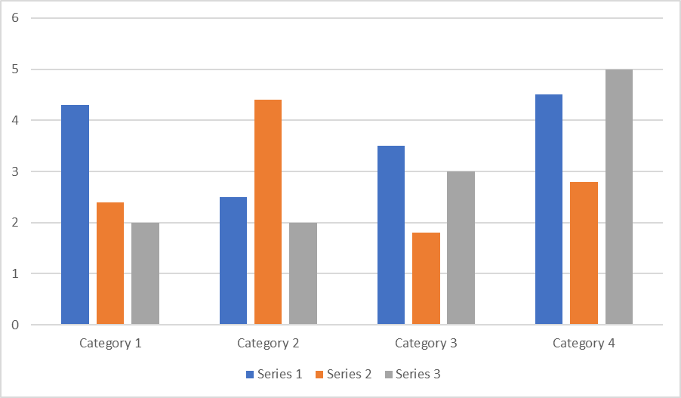

Figure 1 (bold, left justified)
Sample Figure Title (Title Case, italics, left justified)

